1. Inclusion Criteria:
   1. All services are included, including those that are NOT reported via CCS 3, where ClientVisit.rev_timein is within the report period.
   2. Services for test (ZEXCLUDE) and deleted consumers are excluded.
2. Fields:
   1. **COMP**
      1. ~~Hard coded~~ PartnerConfig.paramvalue WHERE PartnerConfig.parameter = ‘partnercode’
   2. **CASE**
      1. ClientVisit.client_id
      2. Should it match CCS 3 by also including the external_id and padding it with leading zeros if necessary? Randy Love at MTM Services said that it doesn’t need to match CCS 3 and to only use the client_id. At the 10/26/2018 DMC meeting, Allen Wass at DBHDS requested that a faux Consumer ID be used for SPQM.
   3. **AlternateID**
      1. Blank – Empty String (“”)
      2. PLACEHOLDER ONLY – Do not populate until further notice.
   4. **DOB**
      1. Clients.dob
   5. **Gender**
      1. Clients.sex
      2. “01” = “F” (Female)   
         “02” = “M” (Male)   
         “98” (Not Collected (Not asked)) is the default.
      3. 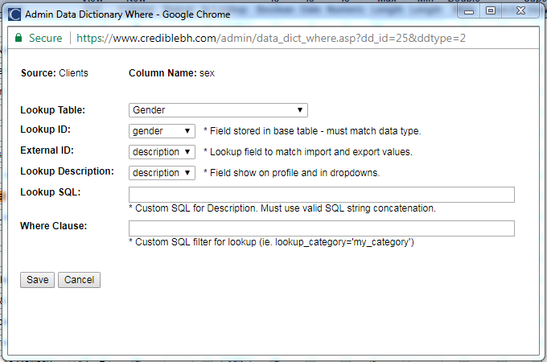
      4. SELECT * FROM Gender  
         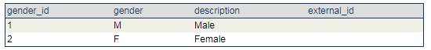
   6. **DIV**
      1. Programs.export_program_code
   7. **UNITNo**
      1. ClientVisit.program_id
   8. **UNIT**
      1. Programs.program_desc
   9. **SUBUNITNo**
      1. Blank – Empty String (“”)
   10. **SUBUNIT**
       1. Blank – Empty String (“”)
   11. **SERVER**
       1. ClientVisit.emp_id
       2. Should it match CCS 3 by also including the external_id and padding it with leading zeros if necessary? Randy Love at MTM Services said that it doesn’t need to match CCS 3 and to only use the emp_id.
   12. **LAST**
       1. Employees.last_name
   13. **FIRST**
       1. Employees.first_name
   14. **STAFFTYPE**
       1. Employees.credentials
   15. **SVCODE**
       1. ClientVisit.visittype_id
       2. Should ClientVisit.clientvisit_id be used instead? Per Randy Love, no.

For the SVCODE field, we're including the unique identifier for the ***type of service***.  Should the unique identifier for the ***service encounter*** be included instead?

I’m not sure how to answer your question.  However the Service Code is usually a code associated with a the name of a Service.  The service names are widely used by the staff providing services.  It is not intended to be an aggregated categorization.  We may pursue categorizations later, but we really want labels for services that direct care staff and managers would readily recognize as the services they provide.  If you already have a file ready, just go ahead and send it.  We’ll evaluate this further in our data profiling.

* 1. **SERVICE**
     1. VisitType.description
  2. **DATE**
     1. ClientVisit.rev_timein (Date Part)
  3. **START**
     1. ClientVisit.rev_timein (Time Part in Military Time)
  4. **STOP**
     1. ClientVisit.rev_timeout (Time Part in Military Time)
  5. **CLIENTTIME**
     1. ClientVisit.duration
  6. **APPT**
     1. Based upon Planner.visit_status, values are hard coded as follows:  
        “01” = “ARRIVED”  
        “02” = “CANCELLED”  
        “03” = “CNCLD BY PROV”  
        “04” = “CNCLD>24hr”  
        “05” = “COMPLETED”  
        “06” = “EMERGENCY”  
        “07” = “NON-CLIENT”  
        “08” = “NOSHOW”  
        “09” = “NOTPRESENT”  
        “10” = “RESCHEDULE”  
        “11” = “SCHEDULED”  
        “12” = “WALK-IN”  
        Blank – Empty String (“”) is the default.
     2. Is there a lookup table in Credible for the Schedule Status?
     3. Should data from the Cancellation/No-Show form be included (see Region Ten’s form below)? It’s possible that not every CSB uses a Cancellation/No-Show form. And, for the CSBs that do use a Cancellation/No-Show form, each one is going to be different. So for these reasons including the data from the Cancellation/No-Show form would make it difficult to compare data across CSBs.  
          
        Per Randy Love: “We sometimes use the Reason characterization and may add it as a part of your practice management consultation later.  No need for that now.”  
        1. 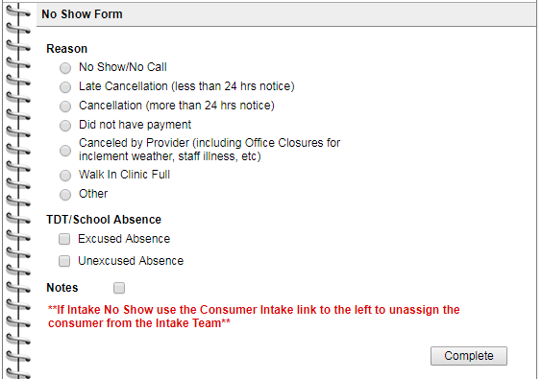
  7. **APPOINTMENT**
     1. Planner.visit_status
  8. **MDCD**
     1. “Y” (Yes) if the consumer had at least one payer/insurance policy that was active ***at any point*** within the report period where Z_PayerType.payertype_code = “03” (Medicaid), “10” (Medicaid Managed Care), “11” (Medicare Medicaid Dual Eligible), or “12” (Medicaid Governor’s Access Plan (GAP).
     2. “N” (No) is the default.
     3. 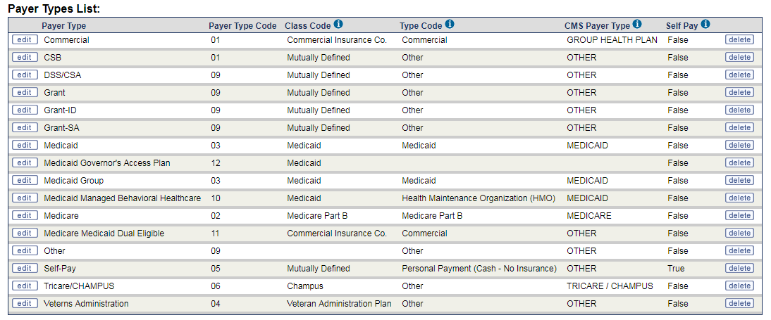
  9. **CPT**
     1. ClientVisit.cptcode
     2. Modifiers are NOT included.
  10. **PAYORBILLED**
      1. Z_PayerType.payertype_code associated with ClientVisitBilling.pri_payer_id
      2. “96” (Not Applicable) is the default for **non-billable** services.   
         “98” (Not Collected (Not asked)) is the default for **billable** services.
  11. **SUPERVISOR**
      1. Last Name, First Name of the first (alphabetically) supervisor assigned to the SERVER (ClientVisit.emp_id) in the EmployeeSupervisor table where is_indirect = 0 (False).
  12. **DX1 – DX8**
      1. Should the diagnoses linked/attached to the service or those found in the consumer’s Problem List be used? Per Randy Love, use the ones found in the consumer’s Problem List.  
           
         For the DX1 - DX8 fields, we're including the diagnoses associated with the service encounter and used for billing (submitting a claim).  Should all (or rather up to 8) of the consumer's active diagnoses be included instead?  They're what's reported to the state.  
           
         We are hoping to get diagnoses of record which might include active diagnoses that may not necessarily be included on a claim
      2. **DX1**
         1. ~~ClientVisit.axis_code~~ ~~ClientVisit.icd10_code~~ ClientAxisDetail.icd10_code WHERE ClientAxis.active_flag = 1 AND ClientAxisDetail.deleted = 0 AND ClientAxisDetail.icd10_code IS NOT NULL AND ClientAxisDetail.problem_list_order = 1
      3. **DX2**
         1. ~~ClientVisit.axis_code2~~ ~~ClientVisit.icd10_code2~~ ClientAxisDetail.icd10_code WHERE ClientAxis.active_flag = 1 AND ClientAxisDetail.deleted = 0 AND ClientAxisDetail.icd10_code IS NOT NULL AND ClientAxisDetail.problem_list_order = 2
      4. **DX3**
         1. ~~ClientVisit.axis_code3~~ ~~ClientVisit.icd10_code3~~ ClientAxisDetail.icd10_code WHERE ClientAxis.active_flag = 1 AND ClientAxisDetail.deleted = 0 AND ClientAxisDetail.icd10_code IS NOT NULL AND ClientAxisDetail.problem_list_order = 3
      5. **DX4**
         1. ~~ClientVisit.axis_code4~~ ~~ClientVisit.icd10_code4~~ ClientAxisDetail.icd10_code WHERE ClientAxis.active_flag = 1 AND ClientAxisDetail.deleted = 0 AND ClientAxisDetail.icd10_code IS NOT NULL AND ClientAxisDetail.problem_list_order = 4
      6. **DX5**
         1. ~~ClientVisit.axis_code5~~ ~~ClientVisit.icd10_code5~~ ClientAxisDetail.icd10_code WHERE ClientAxis.active_flag = 1 AND ClientAxisDetail.deleted = 0 AND ClientAxisDetail.icd10_code IS NOT NULL AND ClientAxisDetail.problem_list_order = 5
      7. **DX6**
         1. ~~Blank – Empty String (“”)~~ ClientAxisDetail.icd10_code WHERE ClientAxis.active_flag = 1 AND ClientAxisDetail.deleted = 0 AND ClientAxisDetail.icd10_code IS NOT NULL AND ClientAxisDetail.problem_list_order = 6
      8. **DX7**
         1. ~~Blank – Empty String (“”)~~ ClientAxisDetail.icd10_code WHERE ClientAxis.active_flag = 1 AND ClientAxisDetail.deleted = 0 AND ClientAxisDetail.icd10_code IS NOT NULL AND ClientAxisDetail.problem_list_order = 7
      9. **DX8**
         1. ~~Blank – Empty String (“”)~~ ClientAxisDetail.icd10_code WHERE ClientAxis.active_flag = 1 AND ClientAxisDetail.deleted = 0 AND ClientAxisDetail.icd10_code IS NOT NULL AND ClientAxisDetail.problem_list_order = 8
  13. **EnhancedCM**
      1. “Y” (Yes – Meets Criteria for ECM) if the consumer had a 923 active episode/open TOC record ***at any ~~point~~ time*** within the report period.
      2. “N” (No – Does NOT meet Criteria for ECM) if the consumer did NOT have a 923 active episode/open TOC record ***at any ~~point~~ time*** within the report period but did have a 920 active episode/open TOC record ***at any ~~point~~ time*** within the report period.
      3. “A” (Not Applicable) is the default.